EEE3096S 2023 Tutorial 2 Hand-in FRSKIA001 CLRCAM007

1. **I2C**
   1. Structure

|  |  |  |  |  |  |  |  |  |  |  |
| --- | --- | --- | --- | --- | --- | --- | --- | --- | --- | --- |
| Start | Address | | | | | | | | ACK  /NACK | 🡪 |
| 1 | 2 | 3 | 4 | 5 | 6 | 7 | R/W |

|  |  |  |  |  |  |  |  |  |  |
| --- | --- | --- | --- | --- | --- | --- | --- | --- | --- |
| Data [0] | | | | | | | | ACK  /NACK | 🡪 |
| 1 | 2 | 3 | 4 | 5 | 6 | 7 | 8 |

…….

|  |  |  |  |  |  |  |  |  |  |
| --- | --- | --- | --- | --- | --- | --- | --- | --- | --- |
| Data [n] | | | | | | | | ACK  /NACK | Stop |
| 1 | 2 | 3 | 4 | 5 | 6 | 7 | 8 |

The Master puts pulls the line low, then puts out the 7 Bit Address of the Slave + a Read/Write bit. It waits for an ACK. If it is acknowledged, the Master sends out a byte at a time, waiting for an Acknowledge after each byte. Then at the end of the message, the Master sends a stop bit

* 1. Reduced pin count. Multiple devices on the same communication lines.
  2. Start and stop conditions

Start condition:

This occurs when the SDA line has a high-to-low transition and SCL line is high.

(1)

Stop condition:

This occurs when the SDA line has a low-to-high transition and SCL line is high.



(2)

* 1. Diagram

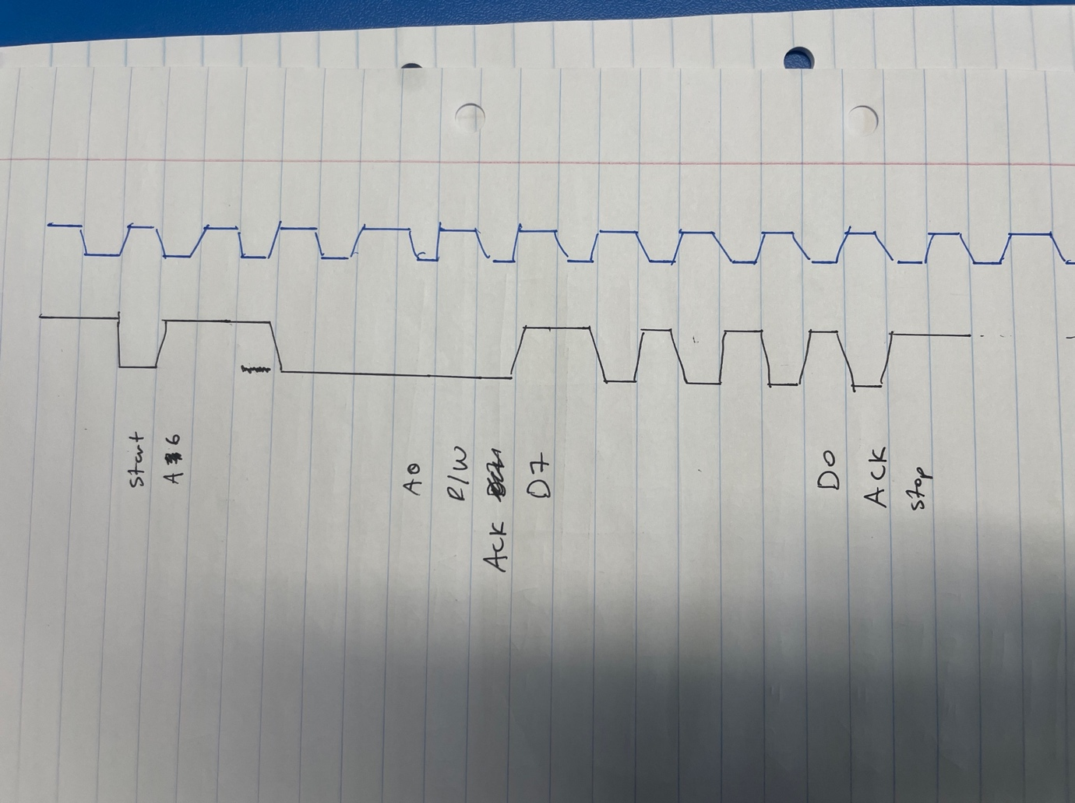

# Binary Coded Decimal (BCD)

1. Explain what Binary Coded Decimal is, and provide an example.

BCD is a method of coding a decimal where each number takes up 4 bits of space as 0-9 is represented at 0000-1001. E.g. 745 = 0111 0100 0101 = 7 4 5

1. Advantage

Allows for easy communication between 10th order decimal-based systems and binary systems. It's easier to understand and create outputs for humans.

Disadvantage

The BCD arithmetic is little more complicated. BCD needs more number of bits than binary to represent the decimal number. So BCD is less efficient than binary. (3)

# Unix Epochs

1. Unix time is referencing computers that count in seconds using an integer starting from the date of January 1, 1970, at 00:00:00 UTC (Coordinated Universal Time). And this is the way that computers used to keep track of time.
2. 1672524000 (4)

# RTS and RISC/CISC

1. Dynamic Synchronous Hard Real-Time System

Is broken into:

Dynamic: arrival of tasks may be unpredictable

Synchronous: The device follows a predefined clock cycle

Hard Real-Time: it is imperative that it is on performs its task on time

1. RISC vs CISC

RISC has far fewer instructions than CISC.

CISC works directly with memory while RISC only accesses registers

# Bibliography

1. **nandland.** youtube. *What is I2C, Basics for Beginners.* [Online] 24 Feb 2015. https://www.youtube.com/watch?v=jFtr0Ha5f-c.

2. **[Online] https://fastbitlab.com/stm32-i2c-lecture-4-i2c-start-and-stop-conditions/.**

**3. tutorialspoint. *Binary Codes.* [Online] 2023. https://www.tutorialspoint.com/computer_logical_organization/binary_codes.htm#:~:text=Disadvantages%20of%20BCD%20Codes&text=The%20BCD%20arithmetic%20is%20little,is%20less%20efficient%20than%20binary..**

**4. converter, Epoch. Epoch converter. *Epoch & Unix Timestamp Conversion Tools.* [Online] www.epochconverter.com.**

**5. Jonathan Valdez, Jared Becker. Understanding the I2C Bus. [Online] 2015. google.com/search?sca_esv=556563504&rlz=1C1CHBD_enZA901ZA901&sxsrf=AB5stBhx77eOrIzO7Pyjhs9U4QaKRU5DDg:1691948919640&q=start+and+stop+conditions+for+i2c&tbm=isch&source=lnms&sa=X&ved=2ahUKEwi9r9TymNqAAxXl_7sIHS8WA0IQ0pQJegQIUxAB&biw=1034&bih=870&dpr=1#imgr.**

**6. openAI. ChatGPT. *ChatGPT.* [Online] 2023. https://chat.openai.com/.**